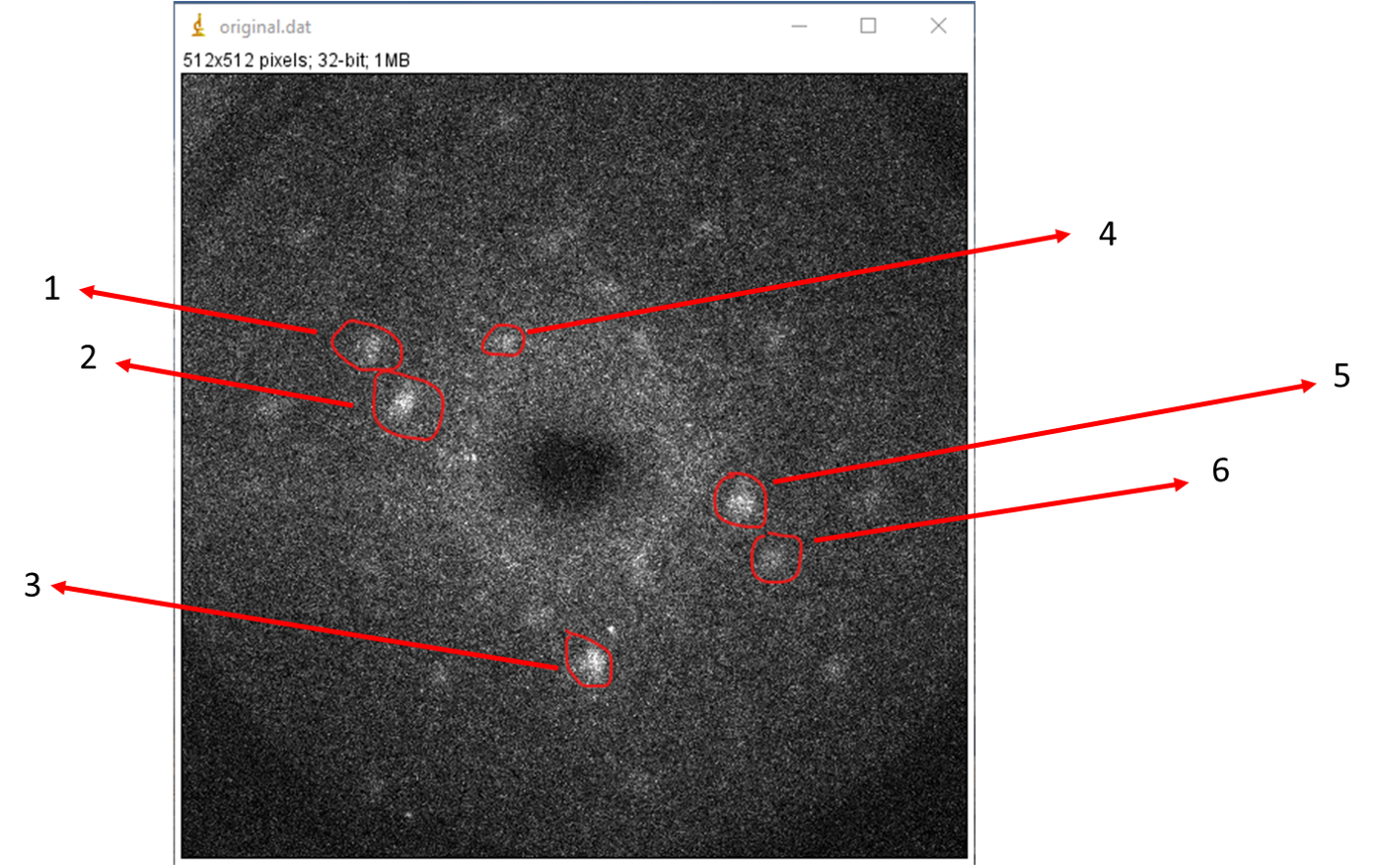Peaks for the indexing

Analysis from ImageJ

Let’s keep length and width of the rectangle or square same; *format: (initialx, initialy, lengthx, lengthy): AND APPROXIMATE MIDPOINTS*

Peak 1: makeRectangle(110, 162, 26, 38); - midpoint: 123, 181

Peak 2: makeRectangle(125, 196, 32, 41); - midpoint: 140, 216

Peak 3: makeRectangle(251, 369, 29, 36); midpoint: 265, 383

Peak 4: makeRectangle(195, 162, 29, 27); midpoint: 210, 175

Peak 5: makeRectangle(347, 267, 31, 28); midpoint: 365, 284

Peak 6: makeRectangle(371, 305, 27, 29); midpoint: 385, 320

Lets make each square